 | Abdi İpekçi Caddesi Kaşıkçıoğlu Apt. No:42 D:2 34365 Nişantaşı İstanbul  www.artxist.com  info@artxist.com  T. +90 212 291 77 84 F. +90 212 343 69 35 | PRESS RELEASE

“x-ist @ ARCOmadrid 2013”

x-ist participates in ARCOmadrid 2013 held from 13-17 February.
This year the fair hosts a selection of Turkish galleries, under the section Focus Turkey,
which aims to arouse interest in Turkish contemporary art. x-ist exhibits the works of
CANAN, Nalan Yırtmaç and Ceren Oykut at ARCOmadrid.

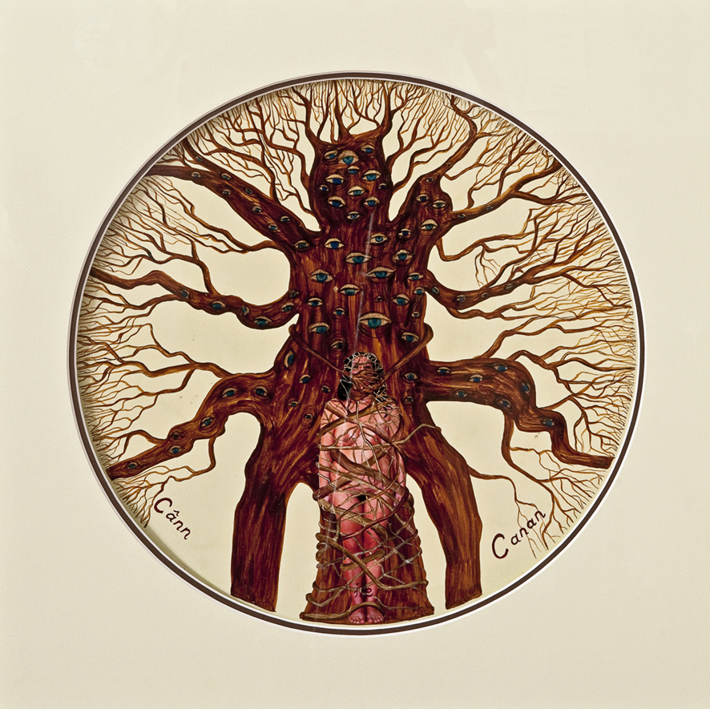

CANAN, Can and Canan, Photography, ink and gold on special paper, 65 x 65 cm, 2011

In the 1990’s CANAN preferred to use a realistic language like videos, photography and documentaries, and usually described her body as a figure in the paintings. In ARCOmadrid, the artist exhibits a selection of later work, photography and miniatures that are intensive both in the visual representation and symbolism. CANAN questions the authority of the rulership mechanisms like government, religion, society and family upon the person and the body.

Nalan Yırtmaç participates in ARCOmadrid with a selection of works from her recent show “Please Move towards the Back II: Disastercity”. Yırtmaç questions the concepts behind the ongoing construction and destruction activities (in Istanbul and different cities in Anatolia) such as the right to shelter, immigration. Her work trails the dream of “finding a place to live” and reminds the ARCOmadrid viewer of the urban transformation that Barcelona went through in the 1990s.

Ceren Oykut’s new series “Condominium” inspired by her last show “With Bells On” takes in hand the urban transformation and the resulting immigration. Oykut draws the ever-changing city scapes and the unaware tourists that try to walk and photograph wherever possible. Besides her new series produces specifically for ARCOmadrid, a selection of previous works by the artist will also be presented at the show.

x-ist welcomes everyone to its booth 10B21 at ARCOmadrid.

